# Assignment 2: Use cases for Capcium E-commerce Platform

Date: 9/28/2022. Group: 5

| **Team member name** | **Student ID number** |
| --- | --- |
| **Justine Castellani** | 40114450 |
| **Carolina Hassid** | 40058449 |
| **Alain Euksuzian** | 40070126 |
| **Loric Vezin** | 40113694 |
| **Thuc Anh Kim** | 40129214 |
| **Farhan Priyonto** | 40107504 |

**Description of the assignment:** Teams will develop ten (10) use cases for the team project that they proposed for the course I assignment 1 that was approved by the instructor. Teams are required to follow the model provided for the information that is required.

Use cases should be 1 page per use case. So, the assignment will have approximately 10 pages

As before, this project will be used for all the assignments in this course during the semester, as we will be evolving this idea towards a more complete system analysis and design.

The assignment must be done in teams of 3 or 4 students. The same teams as assignment 1, unless an arrangement has been made to change the teams.

The assignment is worth 5% of the final grade for this course.

Late assignments will be penalized by 20% per week.

**Key:**

**USE CASE 1 - Sign up for an account**

**Summary**:  
  
As a customer, I want to create an account at Capcium.ca so that I can place my order.

**Owner:** Capcium website manager

**Actor**: New customers

**Preconditions**: No precondition

**Postconditions:** A link received by email will prompt you to the login page, where you can input your credentials.

**Description**: Users must go to the company’s website, where they will have to create an account and supply their name, last name, email and password and click on ‘send email confirmation’. That information must be validated by clicking a link in the validation email. That link will prompt them to the login page where they will be able to sign in using their credentials. Now that they have taken all these steps, they can start adding to their shopping cart.

**Exceptions**:

. If the customer’s information is not valid or if they did not properly fill everything that was requested, they won’t receive an email of confirmation.

. If the customer already has an account, redirect them to the login page and inform them they have an existing account with that email.

. If you already have an account with this email, you won’t be able to create a second account.

**Priority:** High

**Category:** functional /required process

**USE CASE DIAGRAM 1**

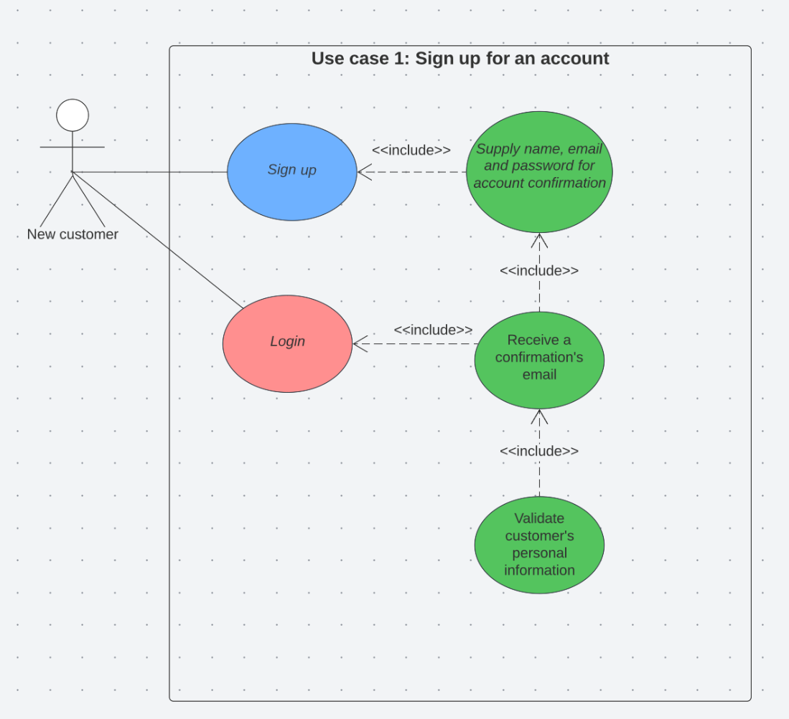

**USE CASE 2 - adding items to shopping cart**

**Summary**:

As a customer, I want to add one or several products to my shopping cart so that I can place my order and pay.

**Owner:** Capcium website manager

**Actor**: Customer

**Preconditions**: Customers must go to the company’s website and log in or sign up if not done yet. They will then either browse the website catalogue and find their desired products or directly select the product.

**Postconditions:** After adding all the products the customers need, they will have to place their order and pay within a specific amount of time.

**Description**: Once the customers are on the company’s website, they will have the opportunity to search for various products. They will have the option to send items to the shopping cart by selecting the quantity of that product (ex: 1, 2, 3, etc.) and its specific package type (ex. 200g, 500g, 1kg, etc.). The shopping cart will be updated each time a product is added. On

**Exceptions**: If the customers want to add a product, but this specific item is out of stock, it will let the customers know.

**Priority:** **High**

**Category:** functional / required process

**USE CASE DIAGRAM 2**

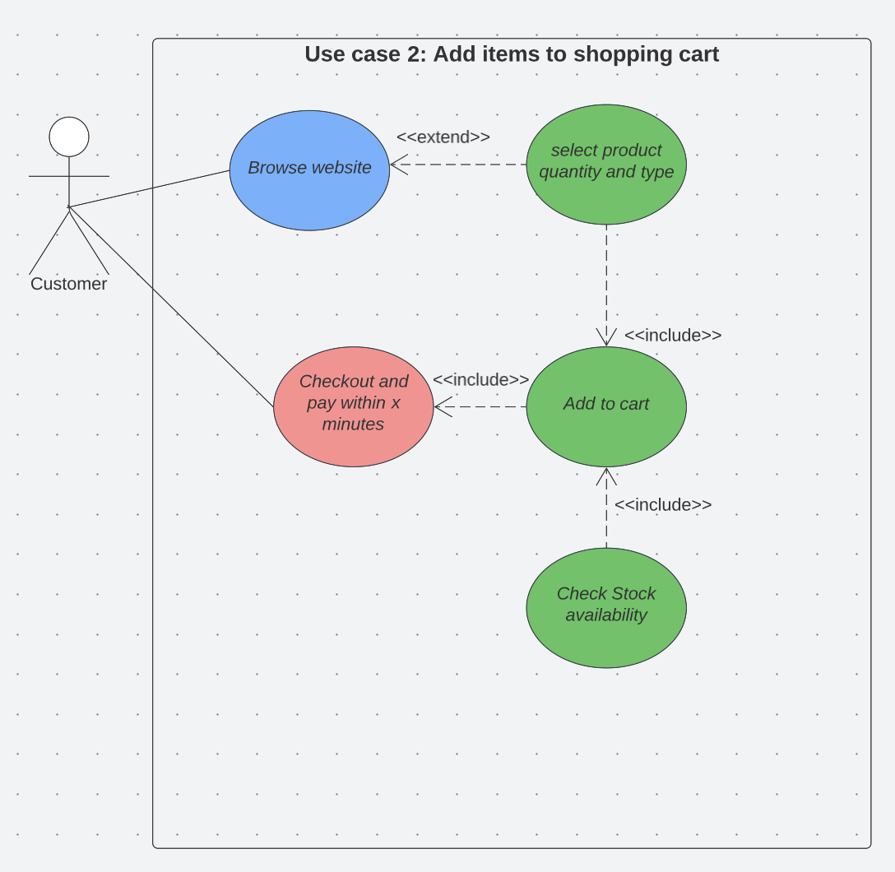

**USE CASE 3 - removing items to shopping cart**

**Summary**:

As a customer, I want to remove one or several products that I no longer want from my shopping cart so that I can place my order.

**Owner:** Capcium website manager

**Actor**: Customer

**Preconditions**: The customer must have items in their shopping cart.

**Postconditions:** After removing all the items that are not desired, the customers can place their order with the updated cart and price and pay within a specific amount of time.

**Description**: The first step is that the customers are on the company’s website and have already added a few items to the shopping cart. Then, they will have the option to remove one or several products from that list. They will also have the opportunity to remove a quantity of a specific product in the shopping cart. For example, if they select three packages for the same item, the users can decide to remove one. The shopping cart will be updated each time a product is removed. Finally, the users can place their order and pay within a time frame.

**Exceptions**: If the customer’s shopping cart is already empty.

**Priority:** High

**Category:** functional / required process

**USE CASE DIAGRAM 3**

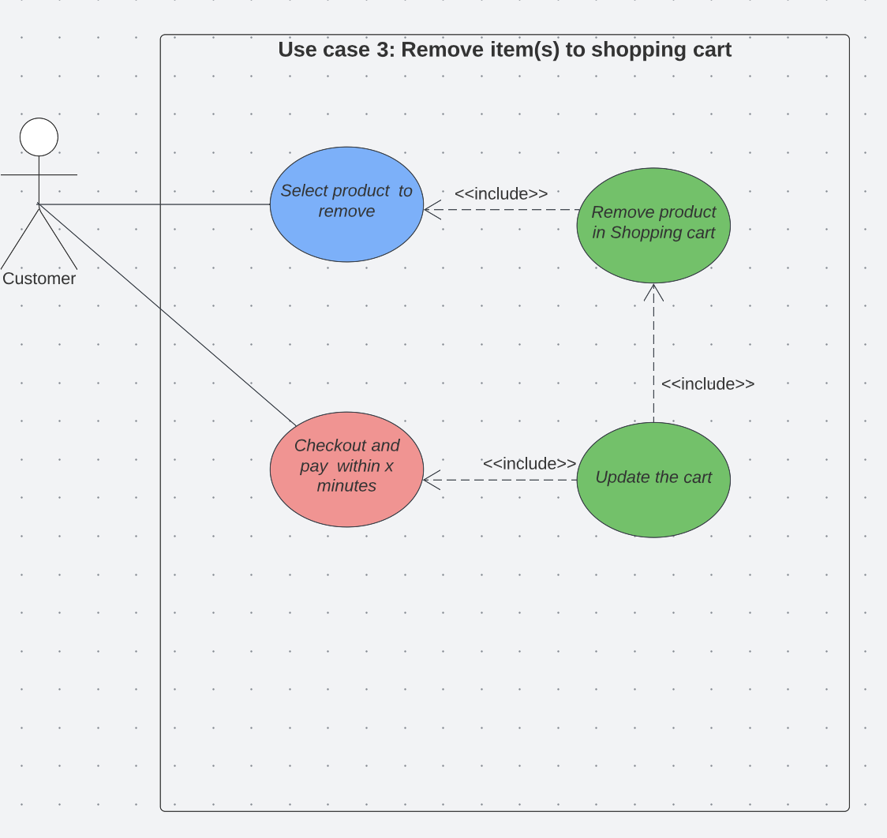

**USE CASE 4 - Checking availability of items**

**Summary**:

As a customer, I want to check to make sure the products I am adding to my shopping cart are still available before checking out and placing my order.

**Owner:** Capcium website manager

**Actors**: Customer, Website owner

**Preconditions**: Users must be on the company’s website. Then, they must choose the items they want to add to their shopping cart. However, for them to add only available products to their shopping cart, the website owner must make sure stock availability is updated in real time through an automated process.

**Postconditions:** If no stock is available, put a label on that product stating ‘This item is out of stock’

**Description**: The first step is that the customers browse the website’s catalogue in order to find the items they are looking for. Before they can add these items to their shopping cart, the website will notify them if they are still available. If there is enough stock, users will be able to add that item to their cart. If not (the item is out of stock), the website will suggest other products with a similar use, and which are available.

**Exceptions**: No exception

**Priority:** **High**

**Category:** functional / required process

**USE CASE DIAGRAM 4**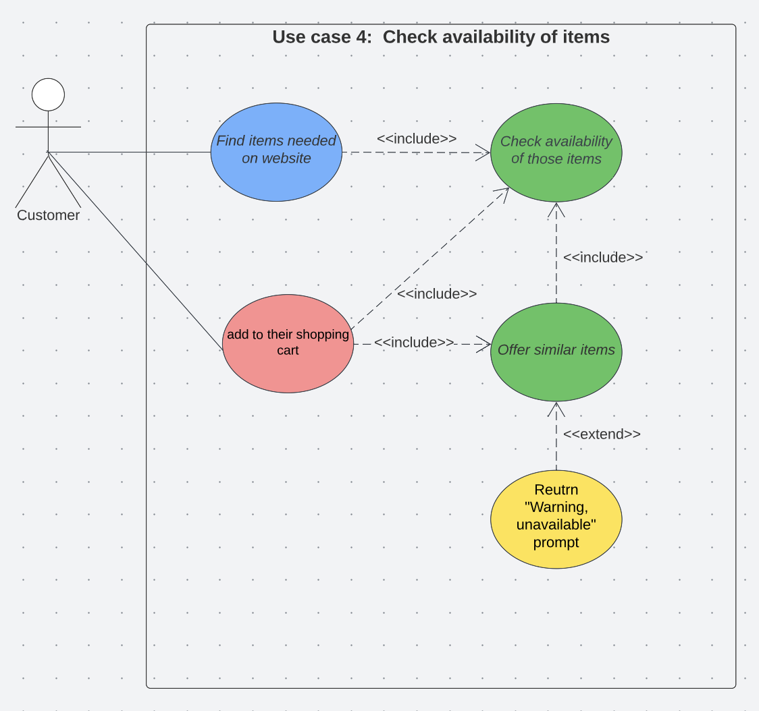

**USE CASE 5 – Product Comparison Page**

**Summary**:

As a website user, I want to see the comparison between products so that I can have an easier time comparing various products and selecting the one I prefer the most.

**Owner:** Capcium Website Manager

**Actor**: Website users

**Preconditions**: The user must first select at least 2 products and click the compare button.

**Postconditions:** There are no Postconditions, the point of this feature is to simply display various products so the user may compare them.

**Description**: The first step is that the user selects two or more products and clicks the “compare” button to let the server start the process. The server then checks that there is enough stock for both products, if there is not enough stock for a given product, a prompt will warn the user. Even if there is no stock for a given product, the two products will still be displayed for comparison but will not be available to the user for later use (adding it to the shopping cart will not be possible).

**Exceptions**: the only exception for this use case is that it will not function with a sole product, a minimum of 2 products must be used.

**Priority:** **Medium**

**Category:** functional / required process

**USE CASE DIAGRAM 5**:

**USE CASE 6 – Order Confirmation**

**Summary**:

As a customer, I want to confirm my order so that I can ensure that the products have been reserved for me and that my payments and delivery addresses were correct so that I may receive my product. I also desire to receive the order ID to keep up with my order.

**Owner:** Capcium Website Manager

**Actor**: All customers (both Guests and Returning Customers

**Preconditions**: For this use case to kick in, the user must have already catered their shopping cart and have registered all their personal information for the order.

**Postconditions:** At the end of the use case, the Actor should have acquired an order number (allowing him to keep track of their order).

**Description**: As the user finishes overviewing their shopping cart and information, they click the “order” or confirmation button which starts the process. The server then rechecks that all the products are available, that the delivery information leads to an actual address, that the payment information corresponds to a bank account that is under the actor’s name. Once this has been done it will then generate an order number and returns it to the Actor. If any of the information is invalid or the products are unavailable, an appropriate prompt will warn the actor and stop the process from generating an order ID.

**Exceptions**: If the user does not have the sufficient funds to pay for the products, the order ID will still be generated but it will be cancelled later, as Capcium receives a message warning them that the payment has not gone through (this can only be checked after the fact).

**Priority:** **High**

**Category:** functional / required process

**USE CASE DIAGRAM 6**

**USE CASE 7 – Uploading documents containing product recipes, procedures, or ingredients**

**Summary:** As a customer, I want to be able to upload files so that I can upload documents containing the formulation recipe of the product. Documents can also contain ingredients list or recommended encapsulation procedures.

**Owner:** Capcium Website Manager

**Actor**: Customers

**Preconditions**: Existing customers must log in

**Postconditions:** The uploaded file gets added to capcium’s production database and distributed between relevant stakeholders.

**Description**: Existing customers log in or sign up on the website. After the process is complete, the customer has to fill in the product questionnaire containing product, company, and general information. Within the questionnaire page, there will be an option to upload files which should include product information, or encapsulation and formulation procedure. The uploaded file is then stored in the Production database and distributed to relevant stakeholders if necessary.

**Exceptions**: Customers unwilling to log in due to privacy or personal reasons will not be able to upload files.

**Priority:** High (Providing own formulation/encapsulation procedure could save the client additional R&D charges as the recipe is critical to production, and without one being provided, R&D has to develop one of their own).

**Category:** Required Process

**USE CASE DIAGRAM 7**

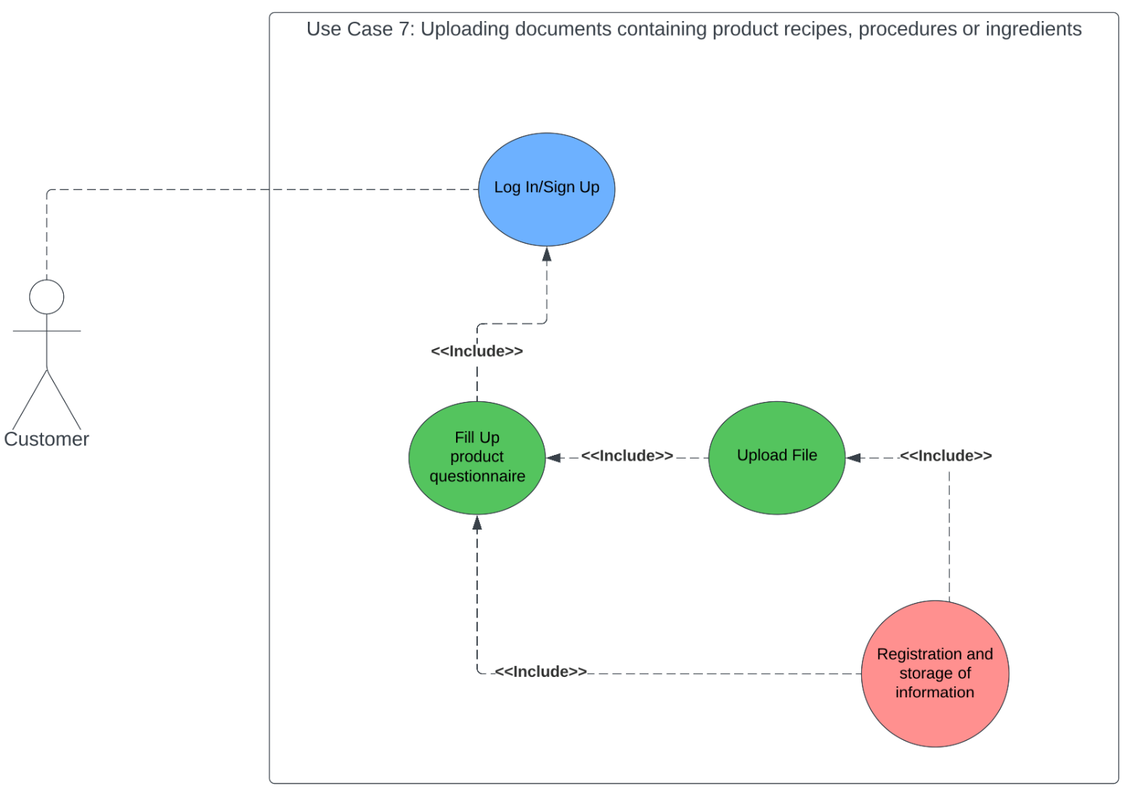

**USE CASE 8 – Receiving files and processing information**

**Summary**:

As the website manager, I want to see how efficiently the overall process of file uploading and information processing works. The flow and proper rhythm of information helps me understand if the information flow is going to the appropriate database and required stakeholders.

**Owner:** Website Manager

**Actor(s)**: Customer

**Preconditions**: Customer must upload the file containing the recipe for formulation/encapsulation or ingredient list.

**Postconditions:** The information is then accessible by authorized departments and individuals, who can use it for their tasks as required.

**Description**: Customer Logs in as required and fills up the product questionnaire. They are also prompted to upload the file containing encapsulation/formulation recipes or ingredients list. The uploaded file is then stored in the production database. The system then extracts product information from the questionnaire and uploads files. This extracted data is then used to populate an internal production database from where an internal document containing all necessary information is made visible to authorized stakeholders.

**Exceptions**: Customers unwilling to sign up due to privacy or personal reasons won’t be able to fill out the questionnaire or upload files resulting in no progression or order.

**Priority:** High

**Category:** Functional/Required Process

**USE CASE DIAGRAM 8**

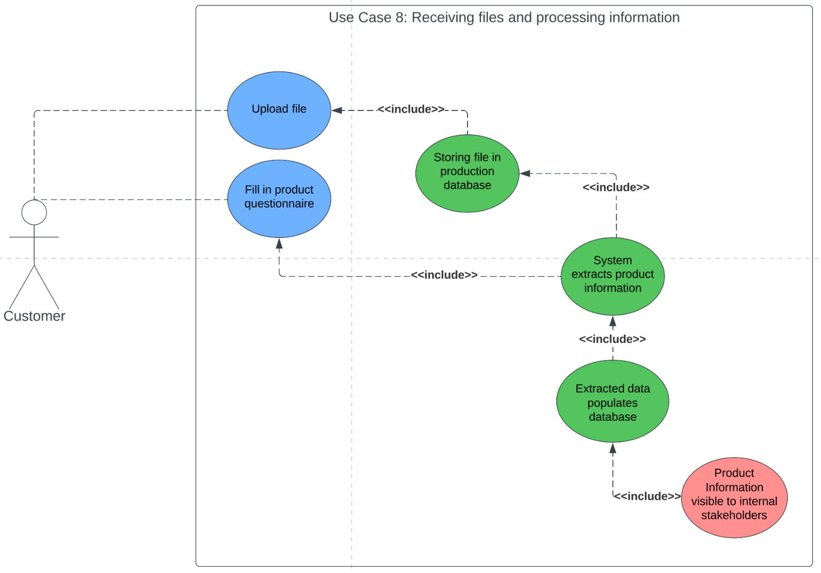

**USE CASE 9 - Update Address Book and Payment Options in Account Settings**

**Summary**:

As a customer, I want to update my default shipping address, billing address and payment options so that I can save time while completing my order at the checkout page.

**Owner:** Website manager

**Actor**: Customers

**Preconditions**: The customer has to have an registered account in Capcium’s database and has to be able to successfully login to their account on Capcium’s website.

**Postconditions:** The customer should be able to see their saved default shipping address, billing address and payment option at the checkout page.

**Description**: After successfully logging-in, the customer goes to Account Settings, where they will see two separate sections: Address Book (for shipping address) and Payment Options (for billing address and payment method). In Address Book, they can add as many shipping addresses as their business requires and an option to set an address as the default shipping address. In Payment Options, they have the option to make their default shipping address their billing address as well or manually enter a different address. They can also select their preferred payment methods and set one of them as the default payment option. The changes made to either section can be confirmed by clicking the “Save” button.

**Exceptions**: No

**Priority:** **High**

**Category:** functional / required process

**USE CASE DIAGRAM 9**

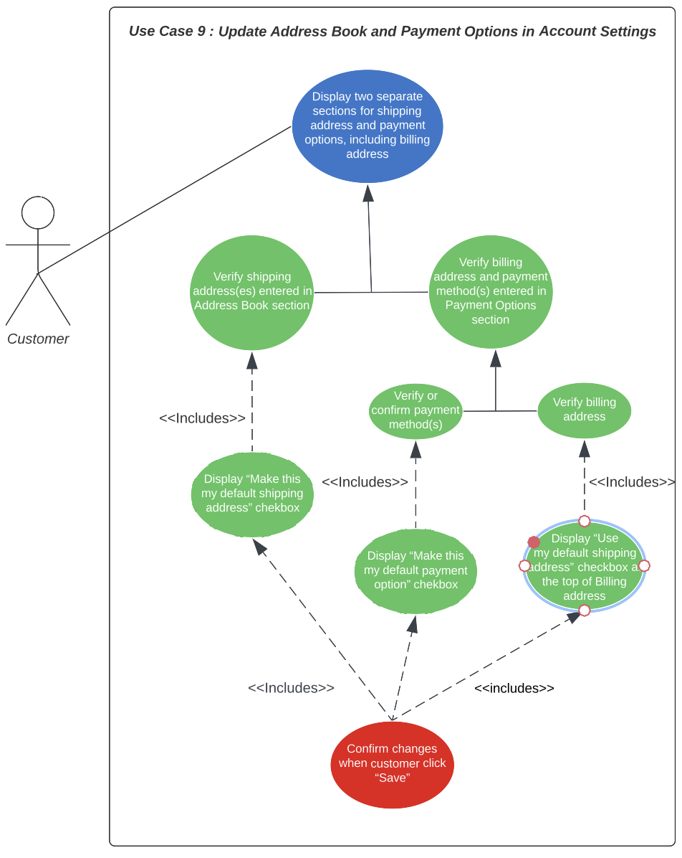

**USE CASE 10 - Verify shipping and billing address at checkout page**

**Summary**:

As a customer, I want to verify my shipping and billing address at the checkout page so that I can complete my order with accurate and up-to-date information.

**Owner:** Website manager

**Actor**: Customers

**Preconditions**: The customer has to have an registered account in Capcium’s database and has to be able to successfully login to their account on Capcium’s website. The customer’s online shopping cart must not be empty.

**Postconditions:** The customer should be able to see their default/ edited/ newly entered shipping address, billing address and payment option in the second step of the checkout page, “Review and Pay”.

**Description**: After successfully logging-in, the customer can browse the website categories, select item(s) and put them in the online shopping cart. Once they click “Proceed to checkout” button, they will be directed to the checkout page, consisting of three steps: “Order details”, “Review and Pay” and “Order placed”. In “Order details”, after Order Summary, there will be two separate sections for Shipping and Billing. Default shipping and billing address will be displayed with an option to edit (if needed). If the customer does not set up default options in Account Settings, they can enter required information in blank text boxes. Then they will continue with the selection of shipping options and payment methods. Once completed, the customer will be directed to the second step, “Review and Pay”, to review the following information before proceeding with payment to complete their order : Order Summary, Shipping address and Shipping option, and Billing address and Payment option.

**Exceptions**: No

**Priority:** **High**

**Category:** functional / required process

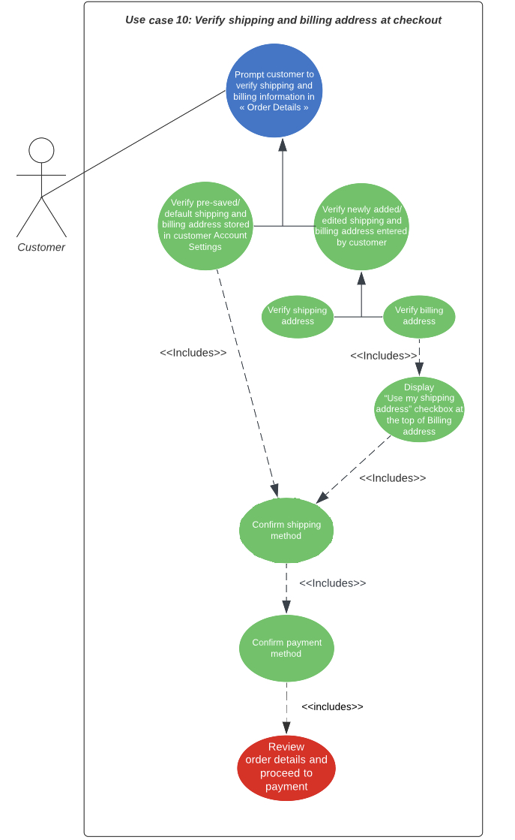**USE CASE DIAGRAM 10**